DEMOGRAPHIC ISSUES IN POLAND

1. Study the chart and discuss your immediate thoughts/conclusions.

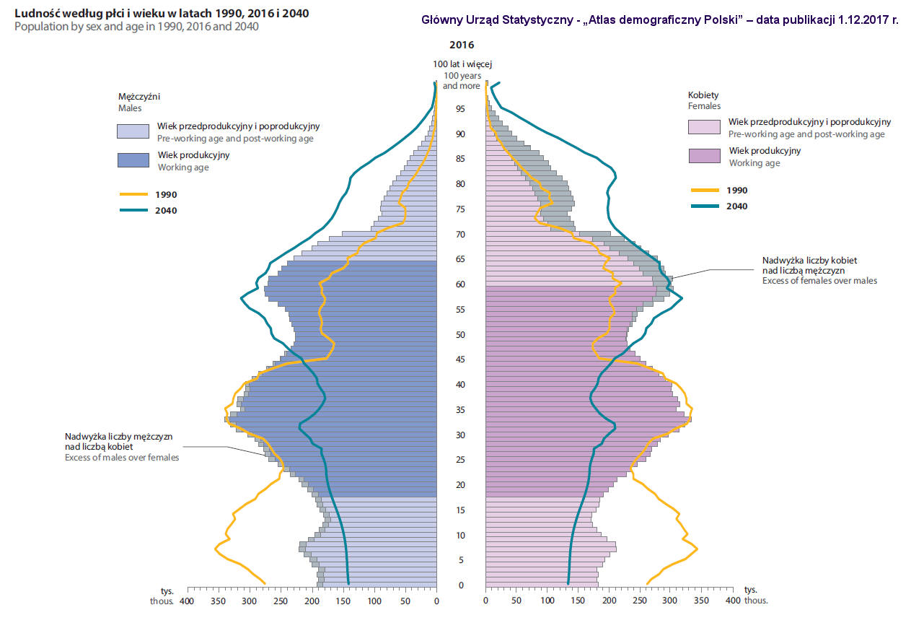
Source: https://geografia.gozych.edu.pl/demografia-polski/#:~:text=Polska%20ma%2038%20432%20992,a%2016%20563%20545%20m%C4%99%C5%BCczy%C5%BAni.

2. What factors have contributed to the plummeting birth rate in Poland? Try to name as many as you can.

1. ………………...........................................................................................................................……….
2. ……………….............................................................................................…….….................……….
3. ………………...............................................................................................……....................……….
4. ………………...................................................................................…………........................……….
5. ………………...............................................................................……...................................……….
6. ………………........................................................................……..........................................……….
7. ………………...............................................................……...................................................……….
8. ……………….................................................…….................................................................……….
9. ………………....................................................……...............................................................……….
10. ………………....................................................…….............................................................……….
11. ………………...................................................……..............................................................……….
12. ………………...................................................……..............................................................……….

3. Read the article and discuss:

A) Did you realise the situation was so serious?

B) Why do you think the countries in Eastern and Central Europe are struggling more?

C) Why didn’t the 500+ programme work?

D) Which countries have a growing birth rate? Could similar solutions be applied in Poland? Why (not)?

Poland’s population to shrink by 23% by 2100 and old-age dependency ratio to double

By Alicja Ptak, APR 20, 2023

Poland’s population, currently 38.5 million, is set to fall to 34.6 million by 2050 and 29.5 million by 2100, according to new Eurostat forecasts. That decline of around 23% is the seventh largest in the European Union over that period. The predicted population drop would have been even greater were it not for an assumed net migration of 5.3 million people over that period to Poland, which currently has one of the EU’s highest immigration rates.
Meanwhile, Poland’s working-age population is set to decline by 4.5 million by 2050 and 10 million by 2100. That will result in the ratio of the elderly to the working-age population doubling over that period and rising from below the EU average to above it.

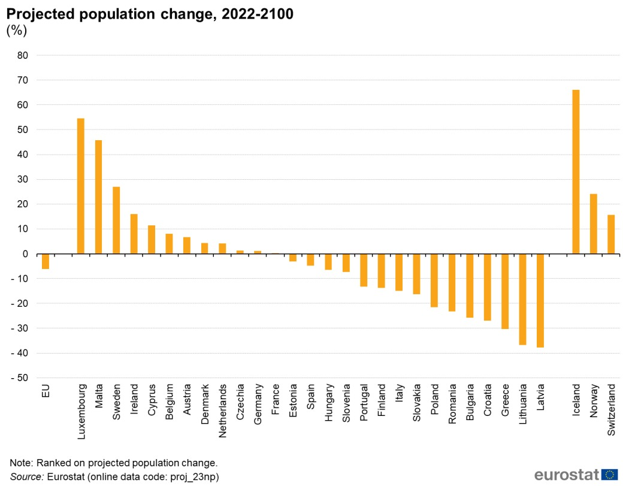

Eurostat’s predictions are consistent with Poland’s recent national census, which has shown that the country’s population is ageing and shrinking. Last year, the number of live births in Poland fell to its lowest level since the Second World War while the number of deaths is rising.
Although last year’s mass arrival of Ukrainian refugees boosted the population – and Poland has also for the last five years running issued more residence permits to immigrants than any other EU member state – its otherwise negative demographics are set to see further decline in coming decades.

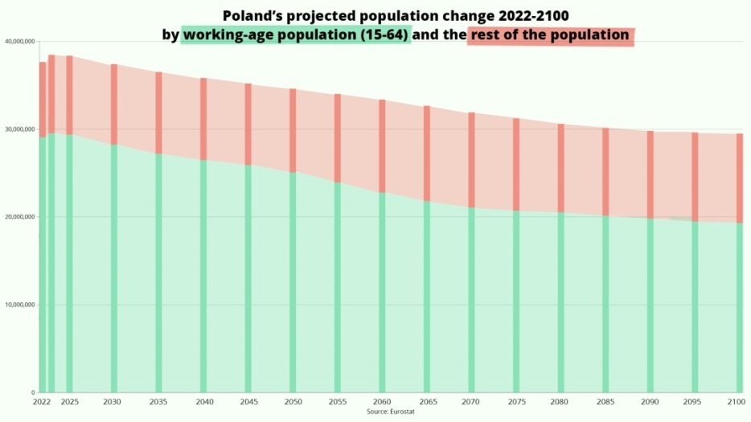

This means that Poland, like most countries in Central and Eastern Europe, may face further demographic challenges, such as labour shortages and the overburdening of the pension system.
Eurostat’s figures show that its old-age dependency ratio – the number of those aged 65+ as a proportion of the 15-64 working-age population – will rise from below 30% in 2022 to over 50% in 2050 and 60% by 2100.
“Population ageing will likely have a considerable impact on public expenditure plans, for example, concerning pensions, healthcare and long-term care costs,” writes Eurostat.

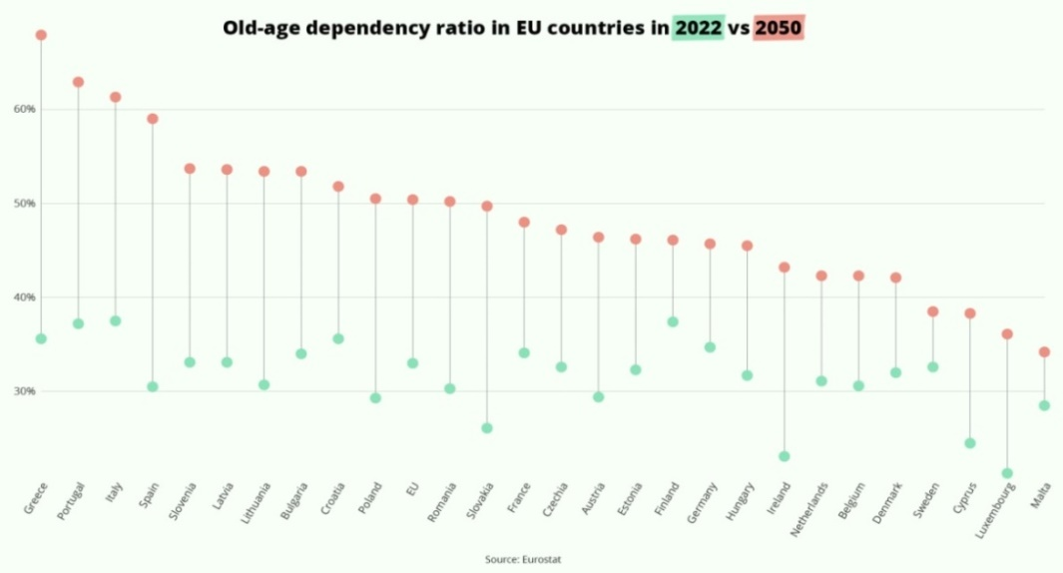

Andrzej Kubisiak, the deputy director of the Polish Economic Institute (PIE), a think tank, notes that the biggest changes in the number of working-age people in Poland will occur not in the current decade, but in the next three.
“Annual changes may be barely noticeable, but the process will clearly accelerate in 8-10 years,” he said, adding that these changes mean that the staff shortages and recruitment difficulties reported by employers in recent years will continue and even worsen.
This means that it will be crucial to increase labour market participation, especially among the young and those over 50, writes Kubisiak.
Source: https://notesfrompoland.com/2023/04/20/polands-population-to-shrink-23-by-2060-and-old-age-dependency-ratio-to-double/

4. Here is some statistical data concerning why reproductive-age people, especially women, do not want to have any/more children. Read the article and discuss whether any data and answers given by the respondents surprised you.
Under a third of Polish women aged 18-45 planning to have children
By Alicja Ptak, JAN 12, 2023 | SOCIETY

The figures come after the introduction in 2021 of a near-total ban on abortion that many believe has made women less likely to want to get pregnant. Recent years have also seen a continual decline in Poland’s fertility rate, despite efforts by the government to boost the number of births.
The new data from CBOS show that 17% of women aged 18 to 45 plan to have children in the next three or four years while 15% say they plan to do so in the longer term. Meanwhile, 68% say that either they are not planning to have children or they do not know whether they will.
By comparison, when the survey was previously taken in 2017, 25% were planning children in the near-term future and 16% in the longer term, while 59% had no such plans or did not know.
CBOS also breaks down the results according to whether respondents already have children or not. Among childless women, the latest survey found that 59% plan to have them in the short- or long-term future, compared to 78% in 2017.
Among women with one child, only 35% plan another (down from 45% in 2017); and among those with two or more children, just 7% do (down from 9% in 2017).
“This decrease [in the percentage of women planning to have children] can be partly explained by the demographic changes that have taken place during this period,” said CBOS in an analysis of its survey, cited by the Dziennik Gazeta Prawna newspaper. “Compared to 2017, in the analysed group, the percentage of younger women, up to the age of 34, has relatively decreased, while the percentage of older women, aged 35-39, and above all those aged 40-45, has increased,” notes CBOS.
However, the pollster also notes that, even when comparing only the youngest 18-24 and 25-29 age groups in both 2017 and 2022, there has been a noticeable decrease in those planning to have children.
A December 2021 poll by Ipsos for OKO.press asked people why women in Poland may not want to have children. It found that the most common responses were that women were worried about work (40%) and that they could not afford to have children (39%).
That was followed by pregnancy being a risk (33%), their home being too small (24%), and them being afraid that the father of the child would not help (19%). The least popular answer was that it is the fault of feminism (11%).
In October 2022, a United Surveys poll for Dziennik Gazeta Prawna and RMF24 found that a narrow majority of Poles, 52%, believe that the new abortion rules, which went into force in January 2021, have made people less likely to have children. Among female respondents, the figure was 67%.
However, in November, Jarosław Kaczyński – chairman of the ruling party – blamed Poland’s low fertility rate on excessive consumption of alcohol by young women. That caused an outcry among the opposition and women’s rights groups.
Kaczyński’s national-conservative Law and Justice (PiS) party has made raising fertility rates in Poland’s rapidly ageing society one of its flagship goals, introducing a number of social programmes designed to financially support families.
Yet, despite this, the number of births in Poland has continued to decline during PiS’s seven years in power, reaching historic lows. The country has one of the EU’s lowest fertility rates and last year recorded the bloc’s second-largest population decline.
Moreover, the infant mortality rate also increased in 2021, reversing a long-term decline, with doctors saying that the new near-total abortion ban is behind that development.
Source: https://notesfrompoland.com/2023/01/12/under-a-third-of-polish-women-aged-18-45-planning-to-have-children/

5. Discuss - What other systemic changes could be implemented if the birth rate remains the same or further decreases? Try to come up with as many ideas as you can.
a) ………………...........................................................................................................................……….
b) ………………...........................................................................................................................……….
c) ………………...........................................................................................................................……….
d) ………………...........................................................................................................................……….
e) ………………...........................................................................................................................……….
f) ………………...........................................................................................................................……….
g) ………………...........................................................................................................................……….
h) ………………...........................................................................................................................……….
i) ………………............................................................................................................................……….
j) ………………............................................................................................................................……….

